DIV

DIV Diving Engineering Co., Ltd

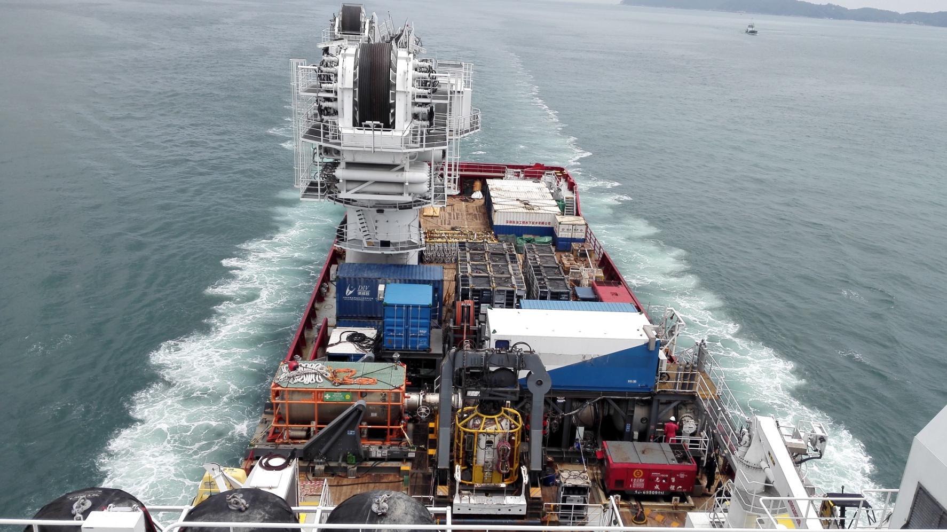

SAT6 300msw/12 man
Saturation Diving System

Specifications DIV

DIV Diving Engineering Co., Ltd

SAT6 300msw/12 man Saturation Diving System

MAIN PARTICULARS

Year built 2014
Builder IUC / Unique
Class Society ABS
Testing/Certification IMCA D018/D024
Standard

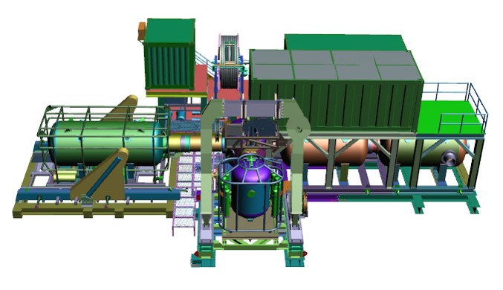

COMPONENTS

Weight Dimensions (L*W*H)
DDC1 with TUP 32.16t 9.14*3.30*3.56
HRC 19.44t 7.55*5.64*3.09
DDC2 18.16t 4.95*3.05*4.44
Bell 30.71t 4.80*4.60*6.71
Sat/Air Diving Control Van 13.60t 7.62*3.05*2.84
Life Support Machine Van 7.50t 6.07*2.91*2.59
Gas Reclaim Van 8.20t 6.07*2.91*2.59
LARS 38.00t 7.01*3.55*5.26
Emergency Generator 6.30t 3.07*2.44*2.59

SERVICES REQUIRED

Electric Power - System 480V, 60HZ
Electric Power – Hot water machine 480V, 60HZ
Emergency generator 250kV 480V,60HZ
Seawater 217Ipm / 50 psi minimum
Fresh Water Domestic potable@30 psi

LIVING ACCOMMODATION CHAMBERS

DDC1 3 man
DDC2 3 man
HRC 6 man

DIVING BELL

Capacity men 3
Diver Lockout Capability 2
Diver Hat Mounted Camera Systems 2
Volume 4.56 m³
Mating to DDC Side
Buoyancy Negative

RECLAIM SYSTEM

Type Lexmar LezGas System
Compressor CompAir
Bell Capacity 2 Diver Reclaim
Dive Control System Divex

HYPE RBARIC EVACUATION SYSTEM

Type Side-off/Float-off HRC
Launch System Self Launching System
Propulsion Tow only
Capacity men 12
Control Van Dedicated w/umbilical

UMBILICAL

Main Bell 350m
Lockout Diver1 45m
Lockout Diver2 45m
Bell men 55m

LIFE SUPPORT MACHINERY

Diver Hot water Unit CDI Supply
CUM Units UTS
Scrubbers DYDRA

Specifications DIV

DIV Diving Engineering Co., Ltd

HAI YANG SHI YOU 289

GENERAL DESCRIPTION

Type MP Subsea Construction Vessel
Design STX OSCV 11L
Built by NB 776 STX Søviknes Norway
Accommodation 100 persons
Gross Tonnage 8922
Net Tonnage 2677
IMO No 9657882
Call Sign BFBC8
Area of Operation Worldwide

Classification

1A1,E0,DYNPOS-AUTR(IMO II),DK(+),
CRANE,HELDK,ICE-1B.DEICE.CLEAN DESIGN,
NAUT-OSV,COMF-V(3),SPS

Main Dimensions

Overall length 120.8m
Length between p.p 111.2m
Breadth molded 22.0m
Depth main deck 9.0m
Draft(max) 6.6m

Deck Equipment

2×Windlass/Mooring winches fwd.Hatlapa
2×Mooring winches aft-Hatlapa
2×Provision cranes-Cargotech/MacGregor 3t

Deck Space

Deck Material Steel/wood
Moonpool Work 7.2×7.2m
Moonpoo ROV 4.8×5.5m
Main Deck Area 1300㎡10t/㎡

DP System

DPII Kongsberg SDP 21(DP2)
Ref.Systems Gyrocompass
3×STD22 Anschutz
2×DGPS(Seatex132&232)
1×Radius 1000
2×Hipap 500
2×Seapath 300

NAV/Com

X-Band / S-Band radar
1×Furuno FE-700 Echo sounder
2×Telchart Dual TECDIS T-2138A
1×Sailor 6110 Sat C
1×Fleet Broadband 250 Sat phone
1×C band VSAT

Power & Propulsion

Main 4×Wartsila 6L32 each 2880 kW(total 11 520 kW)
SCR System
Em.Gen 1×Nogva Scania DI 1262m 285 kW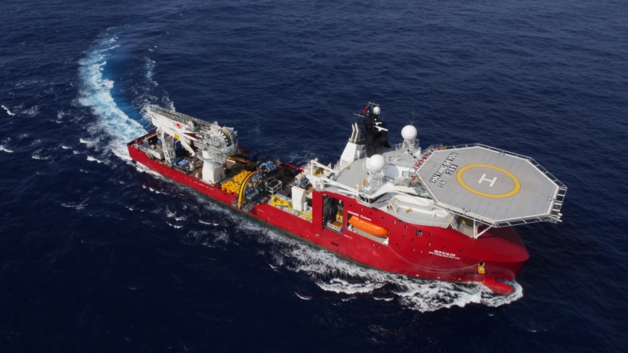

Thruster

Stern 2×RR Contaz 35 (Ice strenghtened) each 3000 kW
Bow 2×RR TT2650 each 1900 kW
1×RR TCN92M each 1500 kW

Rescue

1×Weedo 700-222 hp waterjet
1×Midget 500 mkII-50hp outboard
2×106p Norsafe JYN100 Life boats(100% each side)

Accommodation

100 persons,2 Day rooms,2 Client Cabins
Project meeting room
Conference room
Sky lobby/cinema
Gymnasium
Helideck reception
28 Single Cabin/38 Double Cabins

Helicopter Deck

Supplier Maritime Products AS
Size D=26,1
Aircraft type S92 Sikorsky
Classification NMD,CAP437,MODU1989,DNV

Fuel Consumptions

In Port 3 m³/24 hrs
Transit 25 m³/24 hrs
Full Speed 43 m³/24 hrs
DP 7-15 m³/24 hrs(depend on the weather)

Crane

Offshore Cranes
1×National Oilwell 250t Subsea AHC Knuckle Boom Crane.
Main winch max lifting capacities 250t,
96mm wire, length 2500m.
Operation radius 12-36m,
Aux winch max lifting capacities 20t,
34mm wire, length 2500m.
Operation radius 9-40m.
Deck Cranes
2×Electro-Hydraulic deck/provision cranes
Each crane capacity:3.0t/15m

Specifications DIV

DIV Diving Engineering Co., Ltd

ROV

Schilling HD32 ROV

Vehicle
HPU 150Hp system,112kW
Depth rating 3000m
Vehicle dimensions Length 2900
mm×Width 1700 mm×Height 1900mm
Speed Fwd/Aft 3.2knots
Lateral 2.3 knots
Vertical 2.5 knots
Bollard pull Forward/Aft,900 Kg Lateral,900Kg
Vertical(Up/Down),850Kg
Payload 250Kg
Manipulators 7 function Schilling Titan 4
5 function Schilling Rigmaster
Auto function
Auto Heading/Depth/Altitude/Roll/Pitch
Stationkeep(DP)
Camera (5)Kongsberg
(1 HD color camera fiber output)
(1)TITAN 4 Wrist camera
Lights (10)Variable 120VAC/250W
Pan & Tilt 2 Electric Pan & Tilt Unit
Valve Pack (2)8-function
TMS With 900m tether Capacity
LARS Active Heave Compensated

Schilling HD05 ROV

Vehicle
HPU 150Hp system,112kW
Depth rating 3000m
Vehicle dimensions Length 2500
mm×Width 1700 mm×Height 1900mm
Speed Fwd/Aft 3.0knots
Lateral 2.2 knots
Vertical 2.2 knots
Bollard pull Forward,1000 Kg
Aft,880Kg , Lateral,930Kg
Vertical(Up),465Kg, Vertical(Down),576Kg
Payload 250Kg
Manipulators 7 function Schilling Titan 4
5 function Schilling Rigmaster
Auto function
Auto Heading/Depth/Altitude/Roll/Pitch
Stationkeep(DP)
Camera (5)Kongsberg
(1 HD color camera fiber output)
(1)TITAN 4 Wrist camera
Lights (10)Variable 120VAC/250W
Pan & Tilt 2 Electric Pan & Tilt Unit
Valve Pack (2)8-function
TMS Schilling XE™ 900m tether
Capacity,with 425m tether
LARS Active Heave Compensated

